**E-commerce Application on IBM cloud foundry**

**Project Design and Innovation**

|  |  |
| --- | --- |
| **Date** | **11-10-2023** |
| **Team ID** | **4218** |
| **Project Name** | **E-commerce Application on IBM cloud foundry** |

**Table of Contents**

|  |  |
| --- | --- |
| 1 | Introduction |
| 2 | Problem Statement |
| 3 | Design and Innovation Strategies |
| 3.1 | User-Centric Designs |
| 3.2 | Artisan Profiles |
| 3.3 | Product Listings |
| 3.4 | Secure Shopping Carts |
| 3.5 | Smooth Payment Gateways |
| 3.6 | Product Review |
| 3.7 | Personalized Recommendations |
| 3.8 | Artisan Community and Support |
| 3.9 | Scalability and security |
| 3.10 | Feedback loop |
| 4 | Flow chart |
| 5 | Conclusion |

**1. Introduction**

The objective of this document is to provide an in-depth analysis of the design and innovation strategies for the development of a E-commerce application on IBM cloud foundry. This project aims to utilize innovative approaches to enhance performance, scalability and security.

**2. Problem Statement**

Build an artisanal E-commerce platform using IBM Cloud Foundry. Showcase handmade products, from exquisite jewellery to artistic home decor. Implement secure shopping carts, smooth payment gateways, and an intuitive checkout process. Nurture creativity and support small businesses through an artisan's dream marketplace with high security and performance .

**3. Design and Innovation Strategies**

**3.1 User-Centric Design:**

- Start with a user-centric design approach, considering the needs and preferences of both artisans and customers.

- Implement responsive design for a seamless experience across devices.

**3.2 Artisan Profiles:**

- Allow artisans to create detailed profiles with images, videos, and product descriptions.

- Enable artisans to tell their stories, showcase their creative process, and share their inspirations.

**3.3 Product Listings:**

- Create visually appealing product listings with high-quality images and engaging product descriptions.

- Implement advanced search and filtering options, including material, style, price range, and artisan location.

**3.4 Secure Shopping Carts:**

- Develop a secure and user-friendly shopping cart system with real-time updates.

- Offer the ability to save and share wishlist, fostering customer engagement and repeat visits.

**3.5 Smooth Payment Gateways:**

- Integrate multiple payment gateways, including credit/debit cards, digital wallets, and international payment options.

- Ensure a seamless and secure checkout process with encryption and fraud protection.

**3.6 Product Reviews:**

- Implement a robust product review system that allows customers to leave feedback, ratings, and comments.

- Utilize sentiment analysis to showcase product reviews effectively and help customers make informed decisions.

**3.7 Personalized Recommendations:**

- Utilize machine learning algorithms to provide personalized product recommendations based on browsing and purchase history.

- Suggest complementary products to enhance cross-selling.

**3.8 Artisan Community and Support:**

- Create a vibrant community forum or discussion board where artisans and customers can interact, exchange ideas, and provide support.

- Offer resources, tutorials, and workshops to help artisans grow their businesses.

**3.9 Scalability and Security:**

- Build the platform on IBM Cloud Foundry to ensure scalability, reliability, and security.

- Regularly conduct security audits and updates to protect user data.

**3.10 Feedback Loop:**

- Create a feedback mechanism for users to provide suggestions and report issues.

- Actively engage with user feedback to improve the platform continuously.

**4.FLOW CHART:**

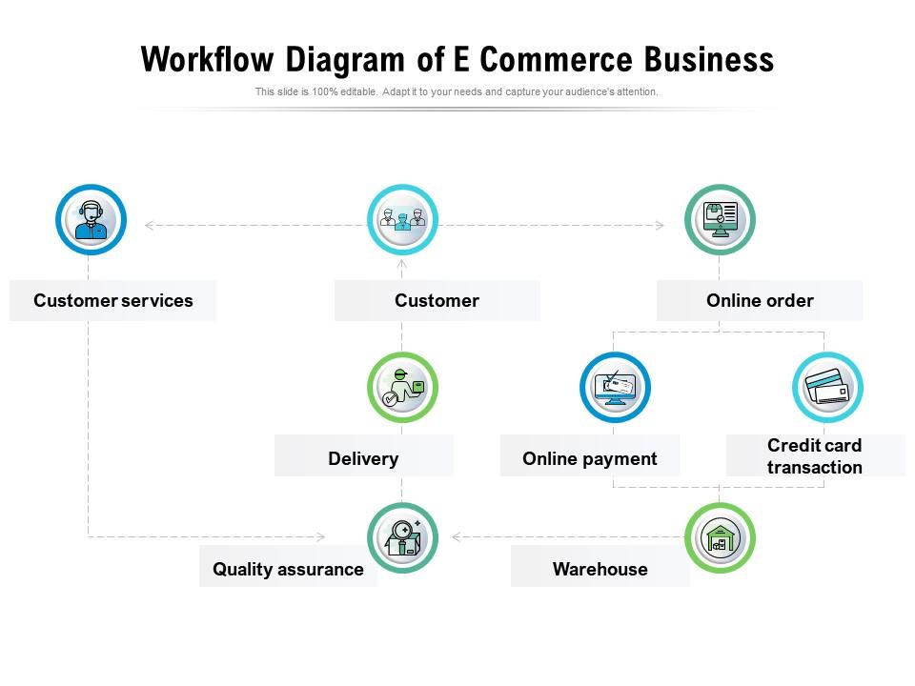

**5. Conclusion**

In conclusion, building an artisanal E-commerce platform using IBM Cloud Foundry with a focus on connecting skilled artisans with a global audience, showcasing handmade products, implementing secure shopping carts, smooth payment gateways, and an intuitive checkout process, while also nurturing creativity, supporting small businesses, and enhancing user engagement and satisfaction, is a visionary project.

The key to success lies in user-centric design, advanced technology integration, a commitment to sustainability and fair trade, and a continuous feedback loop to adapt and improve the platform over time. With these principles in mind, your artisanal e-commerce platform can become an artisan's dream marketplace, benefiting both artisans and customers alike.